Name of Meeting: EPH – Info Gathering Session 1

Date:10/07/2021

Attendees: Tyrell Jarrett, Nadesan Wijendran - Director of EPH, Nigesh N, Jason Nazare, Carmen Malangone, Monika Godara, and Ron Roy

Notes:

Nadesan Wijendran (Director for EPH)- Shared conceptual Architecture- CVS ID/ EPH

EPH is an application for CVS.

EPH stands for Enterprise Person Hub. EPH is an IBM tool, IBM InfoSphere MDM tool. EPH is a facility admin tool.

Its main purpose is to match their demographic data from different lines of business.

EPH gets information from several lines of business. On the screenshot below, the top left-hand side shows the source systems and batch in real time.

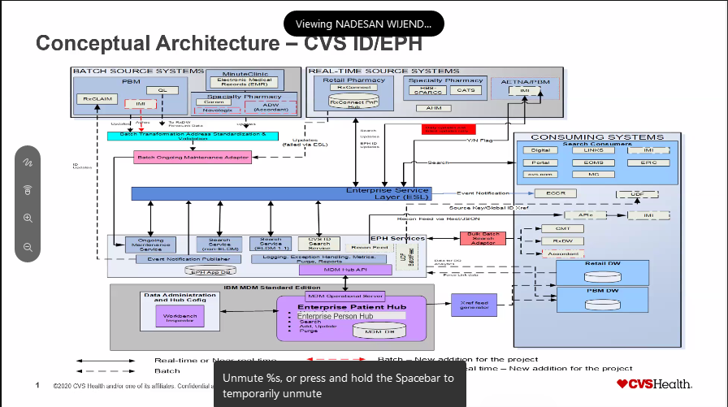

When transaction comes from ESL --> EPH there is IHS Layers which takes care of security protocols. Guidelines are being followed and should be at same level security handshakes between EPH and ESL are required to bypass security protocol then data will come in MDM. If the security protocol fails it will not come to MDM.

Application has never crashed. There was a hardware failure in happened in September 2021 where the HBS card was replaced.

In real time transaction, updates and deletes come from the system. The Enterprise service layer will in turn send a request to EPH. The response will then be sent back.

Informatica is used for the loads. Once loaded, it comes into the DPH database base and backend.

When it comes to demographic information to do a search in EPH, the request goes to yourself, so in turn will send the request to EPH, and EPH will send the response back to yourself.

We also feed the given data warehouse called UDP which is our current warehouse.

Retail PBM gets fed twice a day.

We also allow certain applications to do a batch search. These are campaigns such as flu and diabetes. In both cases they will send us a batch file with demographic information. We do our performance settings and send our response back to them at a high level with a lot of information.

EPA services levels are independent APIs – ongoing maintenance service and SED services.

SED services built between ESL and EPH are with the EPH team.

Monitoring – We follow guideline CVS CIST 006 policy for our 1A tier application and

Capacity is being monitored daily.

Database Monitoring is done through Guardian which is managed by Nadesan’s team and monitored by Splunk team.

Unique IDs are matched with CVS IDs for finding the right person along the lines of business.

Human errors can happen. For an example, a pharmacy technician not asking all questions when a person comes in for a prescription. In Georgia, the technician did not ask for customer’s address. The prescription showed up on someone else account as if they requested the prescription. The data analytics team can look at the data and find the error through the tool.

IBM InfoSphere is on prem. EPH services are on prem.

The database keeps demographic information. There is no transactional data or what the source system sends regardless of the only reason they’re descended is for the purpose of matching. There will be first name, last name, middle name, date of birth, gender, street address, phone number or email if you have it – PII information. Our legal department is not allowed to give this demographic information.

Patching is done by our DB two team. Websphere (MDM v11.6) is done by the rescue team. The rescue team takes care of any kind of admin access.

PBM is updated daily.

We have no interaction with the consumers. Everything goes through yourself. All the security checks are with ESL, not with EPH.

Nadesan will share the upgraded version of metrics of the source record numbers are reaching 2B.

Growth Projections comes from business for capacity planning team. EPH receives projections quarterly 10-15% growth each year. It is on prem and in July 2022 will upgrade everything on AIX servers.

The screenshot below shows metrics for EPH. There are 1.7B records in EPH. There may be some duplicates, just the nature of the business. The only way a new record will get deleted or removed is by the source systems. EPH cannot remove any data under the source systems.

